Creating a New Account
1. Connect the Communicator 2 to your LAN (i.e. your modem).
Users having a local account with no internet access, uncheck the Allow to Manage Farms From the Internet checkbox.
2. In your browser, enter the Communicator 2’s URL address (Munters supplies this information). The Activation screen appears.
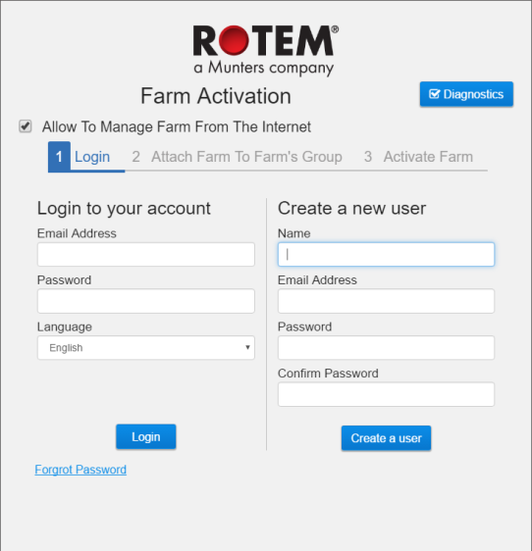
Figure 5: Create a New User
3. Under Create a new user, fill in the fields and click Create a user. The following screen appears.
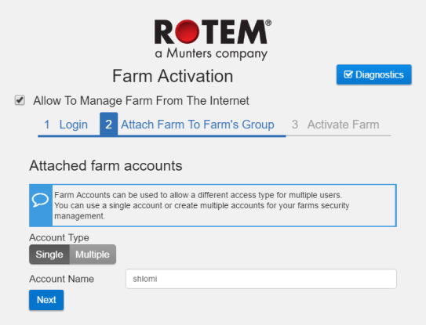
Figure 6: Farm Type
4. Select the Account Type, Single or Multipe.
- Name the account.
- Click Next.
The following screen appears.
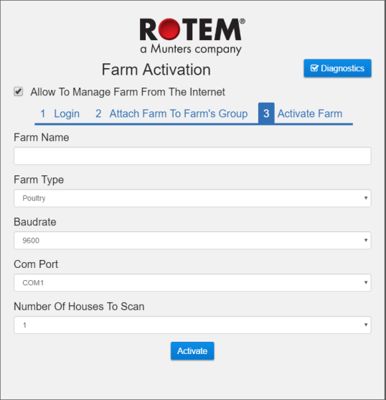
Figure 7: Farm Definition
5. Type in the farm name and define the fields.
6. Click Acitvate.
7. In the following screen, click Start scan.
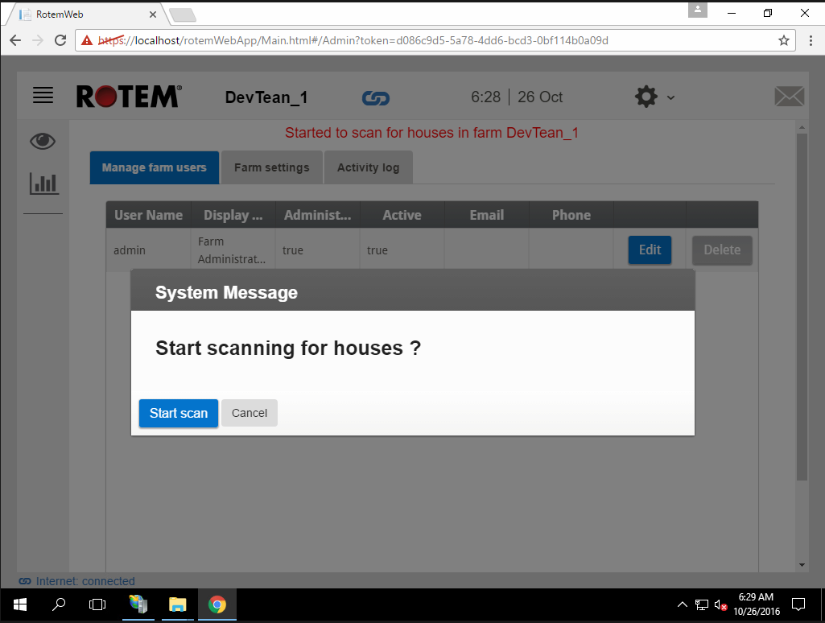
Figure 8: Scan Inititiation
After scanning the controllers, the web application appears:
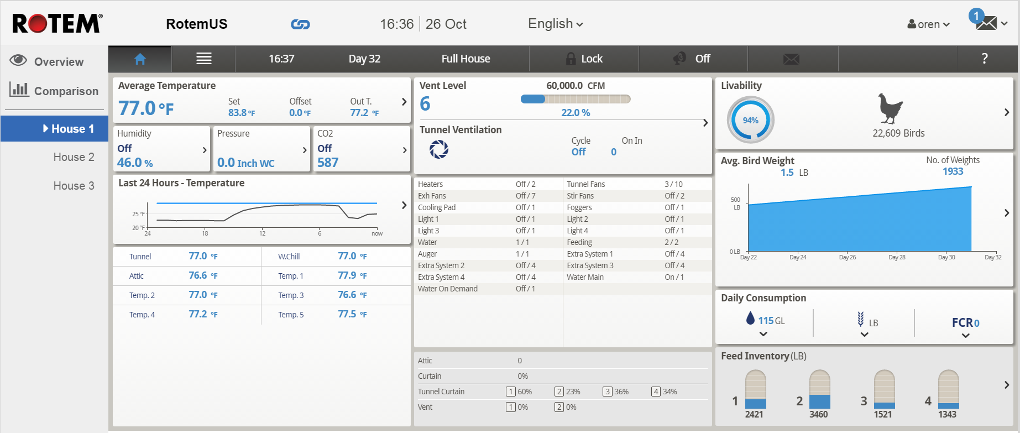
Figure 9: Scanned System (example only)

Login to an Existing Account
1. Connect the Communicator 2 to your LAN (i.e. your modem).
Users having a local account with no internet access, refer to #####
2. In your browser, enter the Communicator 2’s URL address (Munters supplies this information).
The Activation screen appears.
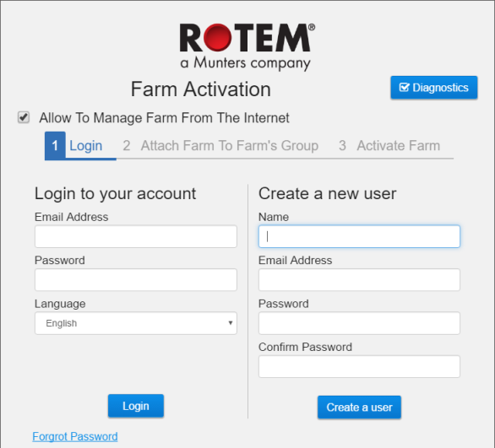
Figure 10: Login screen
3. Under Login to your account, fill in the fields and click Login.
4. In the following screen, click Start scan.
Figure 11: Scan Inititiation
After scanning the controllers, the web application appears (Figure 9).

